DELETE ADMIN FORM

**REQUIREMENT SPECIFICATION:**

**RO5. Functional Description:**

**This is the requirement for removing an admin online. Click on the Delete button**

**Field Validation:**

Delete - Button.

The User after filling the form clicks the “Delete” Button, it removes an admin account which admin wants to delete.

**Before:**

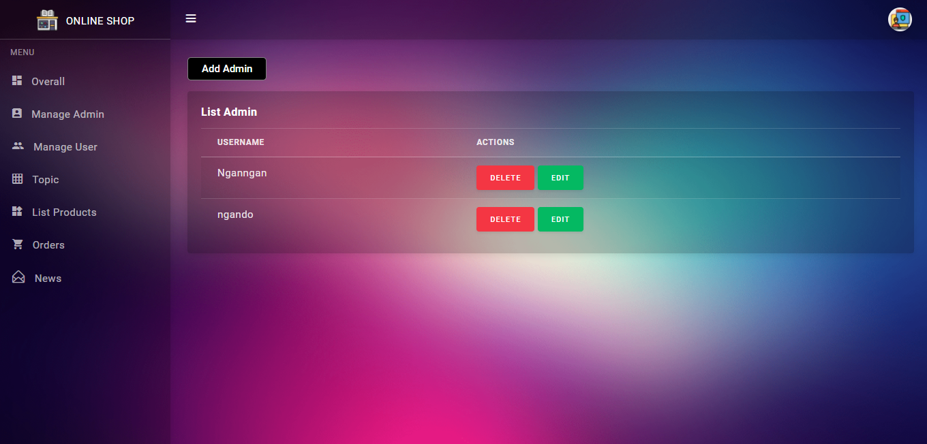

**After:**

